PRACTICAL -08
Aim:
To write a program to implement a Graph and perform searching using Depth First Search (DFS) and Breadth First Search (BFS).
Theory:
A Graph is a data structure consisting of a set of vertices (nodes) and a set of edges connecting pairs of vertices. Graphs can be directed or undirected, and are commonly represented using an adjacency list, where each vertex stores a list of its neighbouring vertices. This representation uses O(V + E) space, where V is the number of vertices and E is the number of edges.
Graph searching (traversal) means visiting every vertex reachable from a starting vertex exactly once. The two fundamental techniques are:
- Depth First Search (DFS): starts at a vertex and explores as far as possible along each branch before backtracking. It uses recursion (or an explicit stack) and a visited array to avoid revisiting vertices.
- Breadth First Search (BFS): starts at a vertex, visits all its neighbours first, and then moves on to the neighbours of those neighbours, level by level. It uses a queue and a visited array, and finds the shortest path (fewest edges) in an unweighted graph.
Both DFS and BFS take O(V + E) time when the graph is stored as an adjacency list. DFS is useful for cycle detection, topological sorting and finding connected components, while BFS is useful for shortest paths and level-order exploration.
Algorithm:
- Create a graph with V vertices and store it as an adjacency list; add all the edges.
- DFS(start):
  - Create a visited array with all values False.
  - Mark the current vertex as visited and add it to the result.
  - For each unvisited neighbour of the current vertex, recursively call DFS on it.
- BFS(start):
  - Create a visited array and an empty queue; mark start as visited and insert it into the queue.
  - While the queue is not empty, remove the front vertex and add it to the result.
  - For each unvisited neighbour of that vertex, mark it as visited and insert it into the queue.
- Display the adjacency list and the DFS and BFS traversal orders.
Program Code:
from collections import deque

class Graph:
def __init__(self, vertices):
self.V = vertices
self.adj = {i: [] for i in range(vertices)}

def add_edge(self, u, v):
# undirected graph
self.adj[u].append(v)
self.adj[v].append(u)

def dfs_util(self, v, visited, result):
visited[v] = True
result.append(v)
for neighbour in self.adj[v]:
if not visited[neighbour]:
self.dfs_util(neighbour, visited, result)

def dfs(self, start):
visited = [False] * self.V
result = []
self.dfs_util(start, visited, result)
return result

def bfs(self, start):
visited = [False] * self.V
result = []
queue = deque([start])
visited[start] = True

while queue:
v = queue.popleft()
result.append(v)
for neighbour in self.adj[v]:
if not visited[neighbour]:
visited[neighbour] = True
queue.append(neighbour)
return result

# Demo
if __name__ == "__main__":
g = Graph(7)
edges = [(0, 1), (0, 2), (1, 3), (1, 4), (2, 5), (2, 6)]
for u, v in edges:
g.add_edge(u, v)

print("Adjacency List:")
for v in g.adj:
print(v, "->", g.adj[v])
print("DFS traversal from vertex 0:", g.dfs(0))
print("BFS traversal from vertex 0:", g.bfs(0))

Output:
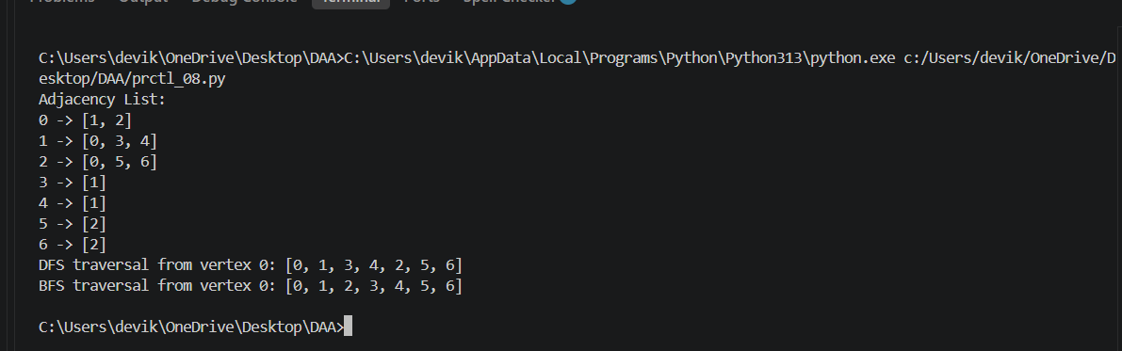

Result:
The program successfully implements a Graph using an adjacency list and performs searching using DFS and BFS. Starting from vertex 0, DFS visits the vertices in the order 0, 1, 3, 4, 2, 5, 6 and BFS visits them in the order 0, 1, 2, 3, 4, 5, 6. Both traversals run in O(V + E) time.

